Welcome to the
52nd Annual Meeting of the
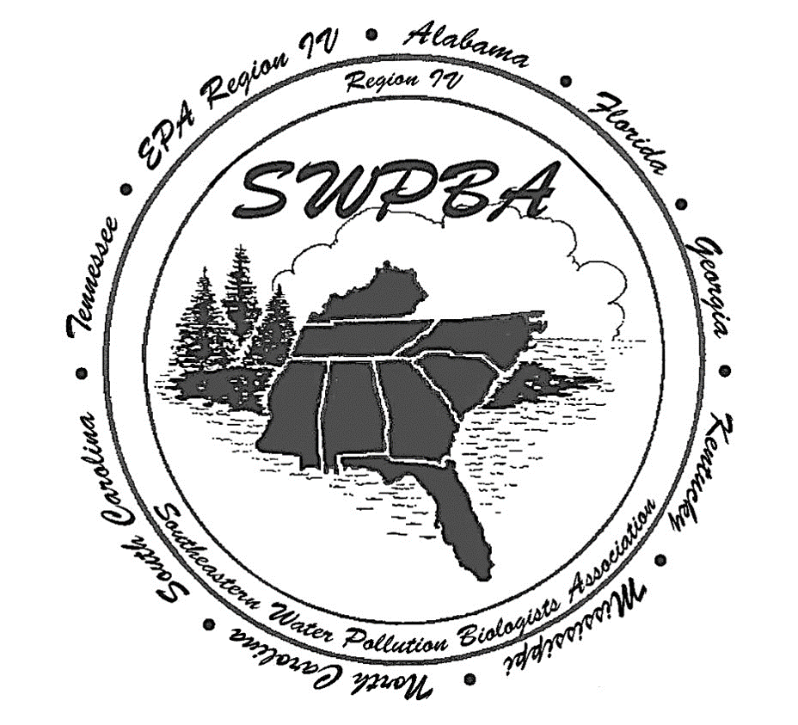

October 6-9, 2025
Apalachicola, Florida

Welcome SWPBA Members and Invited Guests!

We are so happy you made the trip here to historical Apalachicola, Florida for the 52nd Annual Meeting of the Southeastern Water Pollution Biologists Association. To all attendees, speakers, panelists, and sponsors, thank you all for your contributions to SWPBA and making the meeting a success year after year.

President

Todd Risk

Secretary
Josh Farre

Local Committee
Joy Jackson
Aaryn Letson
Sarah Noble
Ashley O’Neal
Jessica Patronis
Amelia Rankin
Cheryl Swanson

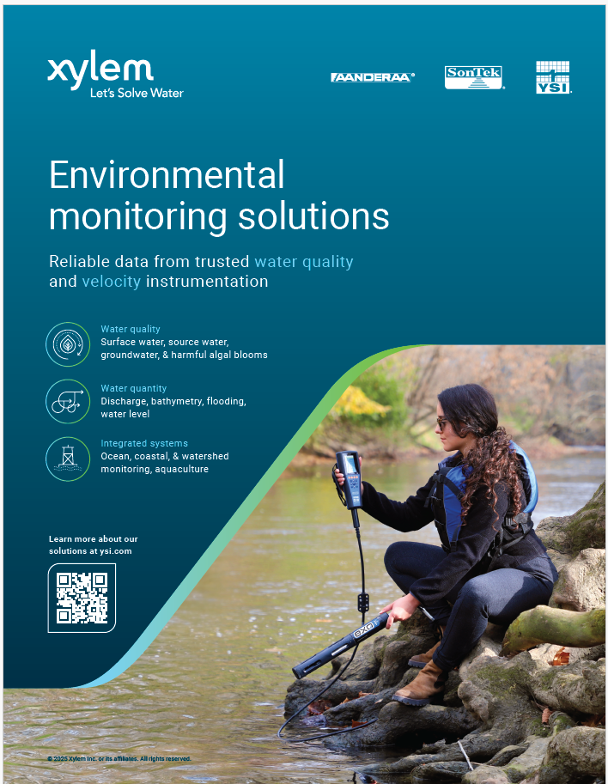
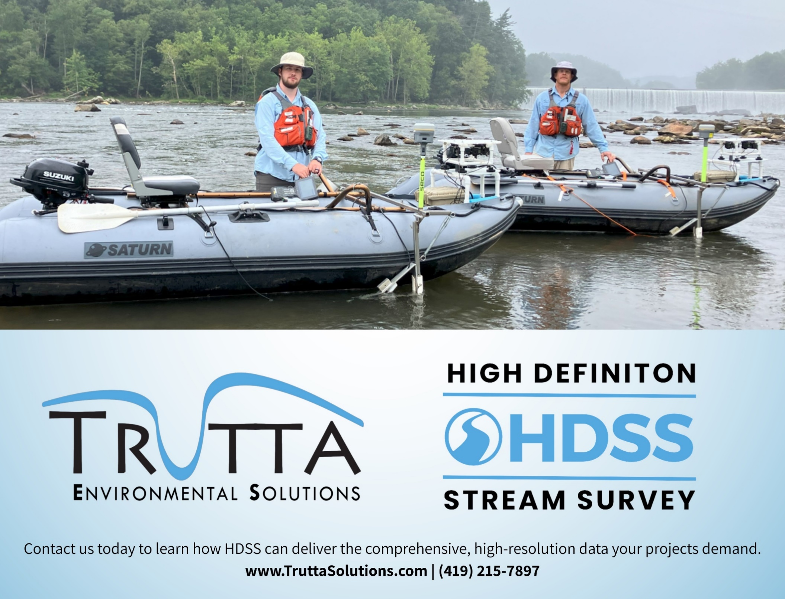



Thank You!
Special thanks to our host, the Apalachicola National Estuarine Research Reserve, especially Megan Lamb for her welcome presentation!
Sponsors
Brett Connell, Trutta Solutions
brett.connell@truttasolutions.com

Ronnie Colón, Martin Microscopes
www.martinmicroscope.com

FlowCam by Yokogawa Fluid Imaging
info@fluidimaging.com

Andrew Crowder, Xylem Analytics
Andrew.Crowder@xylem.com
52nd Annual Meeting
Southeastern Water Pollution Biologists Association
October 6-9, 2025
Apalachicola, Florida

Agenda
All activities take place at the Apalachicola Estuarine Research Reserve (ANERR) unless otherwise noted.

Monday, October 6
1:00-4:00 PM Chironomidae Workshop – Todd Risk – SWPBA President/FDEP Biology Program (see below for details)
3:00- 4:00 PM Registration and Vendor Set up
5:00 – 7:00 PM Gibson Inn Lobby and Porch Mixer

Tuesday, October 7
8:00 – 8:30 AM Registration, Vendor Set-up
8:30 – 8:45 AM Welcome and Meeting Kickoff – Todd Risk – SWPBA President/FDEP Biology Program
8:45 – 9:45 AM ANERR and Research Overview (Megan Lamb)
Session 1: Harmful Algal Blooms
9:45-10:15 AM Florida DEP Freshwater Harmful Algal Bloom Response - Cheryl Swanson, FDEP Biology Program
10:15-10:45 AM Use of FlowCam Technology in Algal Monitoring – Chelsea Lam & Vicki McGee – FDEP Biology Program
10:45-11:00 AM Break
11:00-11:30 AM Building Tennessee’s HABs Response Program: Lessons, Challenges, and Progress —Jessica Rader, TDEC, Division of Water Resources
11:30-12:00 PM HAB Regional Discussion—Region 4 states and EPA—Seth McWhorter, moderator, US EPA Region 4 Water Division
12:00 – 1:30 PM Lunch
Session 2: New Approaches and Innovative Technologies
1:30-2:00 PM Springs Monitoring of Submersed Aquatic Vegetation – Moving Forward With New Technology- Jodi Slater, St Johns River Water Management District
2:00-2:30 PM High-Definition Stream Survey (HDSS): Addressing Water Quality Challenges in the Hurricane Creek Watershed – Brett Connell – Trutta Solutions
2:30-3:00 PM Reference Trend Network (Including SEMN): Preliminary analysis – David Smith – KY Division of Water
3:00-3:15 PM Break
3:15-3:45 PM 5 Year Trends from Kentucky’s Statewide Probabilistic Stream Monitoring Program—Sara Craft, Kentucky Division of Water
3:45-4:30 PM Blackwater Streams Project Update—David Chestnut, South Carolina Department of Environmental Services
4:30-5:00 PM Blackwater Stream Dwellers—Justin Lewandowski, South Carolina Department of Environmental Services
6:00-9:00 PM Evening Social—Eastpoint Beer Company (and Pizza)

Wednesday, October 8
8:00 AM--8:30 AM Registration
Session 3: Extreme Weather Events – Monitoring
8:30-9:00 AM Hurricane Helene Effects on Benthic Macroinvertebrates in Eleven North Carolina Streams – David Harwood – North Carolina Div. Water Resources
9:00-9:30 AM Hurricane Helene: Impacts and Recovery in Tennessee—Shawn Puckett, TDEC Office of Emergency Management
9:30-10:00 AM Hurricane Impacts Along the Springs Coast (FL) – Madison Trowbridge, PhD. – Southwest Florida Water Management District
10:00-10:30 AM Break
Session 4: Ecological Restoration and Invasive Species Management
10:30-11:00 AM Restoration of Crooked Creek after Dam Removal – Nia Wellendorf – FDEP Water Quality Standards Program (WQSP)
11:00-11:30 AM Spearfishing the Invasive Armored Catfish at Blue Springs State Park -- Katie March – FDEP Central Regional Operation Center (ROC)
11:30—12:00 PM All Hands on Deck: Community-Driven Restoration in Choctawhatchee Bay– Kayla Wingard -- Choctawhatchee Basin Alliance
12:00-12:45 PM Lunch (except officers have SWBPA Business Meeting) LUNCH WILL BE PROVIDED at ANERR!
**(12:00 – 12:30 PM) SWPBA Business Meeting (Officers Only) All others on lunch break!**
12:45 – 5:30 PM Field Trip -- Florida State University Coastal Marine Lab ( includes travel time; carpool from ANERR at 12:45 for 1:30 arrival at FSUCML; depart FSUCML at 4:45)
Dinner on your own! Explore Franklin County!

Thursday, October 9
Session 5: Special Projects in Biologial Assessment, Monitoring Updates
8:45 –9:15 AM An Algae and Macrophyte Survey Pilot Project for Springs in Florida – Ashley O’Neal – FDEP Aquatic Ecology and Quality Assurance (AEQAS)
9:15 –9:45 AM Reference Stream Monitoring – Joy Jackson – FDEP Aquatic Ecology and Quality Assurance (AEQAS)
9:45 –10:00 AM Break
10:00 –10:30 AM Environmental Stressors of Southeastern US Stream Fish Communities: An Integrated Modeling Approach Using Water Quality, Habitat, and Landscape Predictors—Justin Bagley, Ph.D.-- AL Dept. of Env. Management
10:30-11:45 AM Updates from all Region 4 States—Roundtable (share from your state an achievement, a current challenge, and a future objective)
11:45 –12:00 PM Wrap-Up & Adjourn

Photo credit: Todd Risk
Chironomidae Workshop
Monday, October 6th, 1:00 – 4:00 pm
Todd Risk, Florida Department of Environmental Protection Biology Program
Todd will facilitate a 3 hour workshop on Chironomidae. Please bring any Chironomidae slides which you would like identified or confirmed. Todd will focus on speciating Tanytarsus as that’s often the most difficult group, and Todd’s favorite genus! You may also bring a thumb drive….Todd can load photos from FDEP’s digital reference collection which may be of some use in helping with future IDs. If you can’t make the Monday workshop, Todd will look at your midges throughout the week.

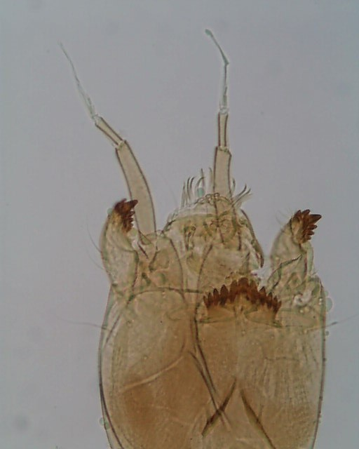

Local Information

Meeting:
Apalachicola National Estuarine Research Reserve
108 Island Drive (State Road 300)
Eastpoint, Florida

Hotels:
Gibson Inn
51 Ave. C
Apalachicola, Florida

Best Western
249 US Hwy 98 E
Apalachicola, Florida

State, National, and Local Parks; Historic Attractions
St. George Island and St. Vincent Island
Dr. Julian G. Bruce St. George Island State Park | Florida State Parks
Gulf of Mexico and St. George Sound access; great fishing and beachgoing
1900 E. Gulf Beach Drive
St. George Island FL 32328
St. George Island Lighthouse and Museum Cape St. George Light - St. George Island Lighthouse Museum & Gift Shop
2B East Gulf Beach Drive
St. George Island, FL 32328

St. Vincent National Wildlife Refuge | Visit Us | U.S. Fish & Wildlife Service
St. Vincent is an undeveloped barrier island accessible by boat only. No amenities or marked trails on the island. Excellent bird watching and wildlife viewing. There is no transportation offered by the Refuge, but there are outfitters who offer it (one example: St. Vincent Island Shuttle Services & Fishing Charters - Apalachicola, St. George Island, Eastpoint Florida )
For more information, the Refuge office is in Apalachicola:
St. Vincent National Wildlife Refuge
96 5th St.
Apalachicola, FL 32320
Downtown Apalachicola
John Gorrie Museum State Park | Florida State Parks
Concern for his yellow fever patients motivated Gorrie to invent a method for cooling their sickrooms. He became a pioneer in the field of air conditioning and refrigeration by inventing a mechanical device that produced ice. In 1851, Dr. Gorrie received the first U.S. patent for mechanical refrigeration.
Chapman Botanical Gardens | Florida State Parks
Named after Dr. Alvan Chapman, a 19th-century botanist (and doctor). He was the author of “Flora of the Southern United States,” the first book outlining many species of plants in the South. Chapman is also credited with the discovery of various rare plants in Florida, and Chapman oak and Chapman’s rhododendron were named after him. Located on North Market Street, adjacent to the Orman House Historic State Park. Open Thursday through Monday, 9:00 a.m. to 5:00 p.m.
Battery Park and the City Marina (no website)
Boat launch, park with picnic tables and great playground; Bay Avenue at 4th-6th Streets

Places to Eat and Drink
There’s a Piggly Wiggly grocery store in Apalachicola and on St. George Island!
Restaurants we’ve tried and like:
Downtown Apalachicola
Up The Creek (Amazing view of the river!) Burgers, seafood, OYSTERS!
The Station Raw Bar (mere feet from the Gibson Inn) OYSTERS!
Hole In The Wall OYSTERS!
The Owl Café Soups and sandwiches
Half Shell Dockside (North Apalach)…fried seafood. OYSTERS!
Franklin Café Soups, sandwiches, burgers.
Eastpoint
Lynn’s Quality Oysters OYSTERS! (duh). Seafood.
Family Coastal Restaurant OYSTERS! Seafood.
St. George Island
Paddy’s Raw Bar OYSTERS! Seafood. Burgers.
BJ’s Pizza Ummmmm…..pizza.
Blue Parrot (Ocean view!!!!!!!). Grouper sandwiches. OYSTERS! Burgers. Fried everything.
Bars/Breweries
Apalachicola
High Five Dive Bar. Fun.
Buoy Brewing (new…Todd [resident beer nerd] hasn’t tried it but hears mediocre things.
Watercraft Brewing Not half bad. Some might even say pretty ok!
Belle’s Winery And Saloon Looks cool. Great location. Haven’t been.
Owl Taproom Good food and good selection of beers. Was closed last 2 times I was in the area but it SAYS it’s open.
Apalachicola Bee Company Haven’t been. Looks quaint. Wine. Mead?
Eastpoint:
Eastpoint Beer Company Meeting there Tues for pizza and beer. Yum.
St. George Island:
Nothing. Paddy’s Raw Bar and Blue Parrot are your best bets.

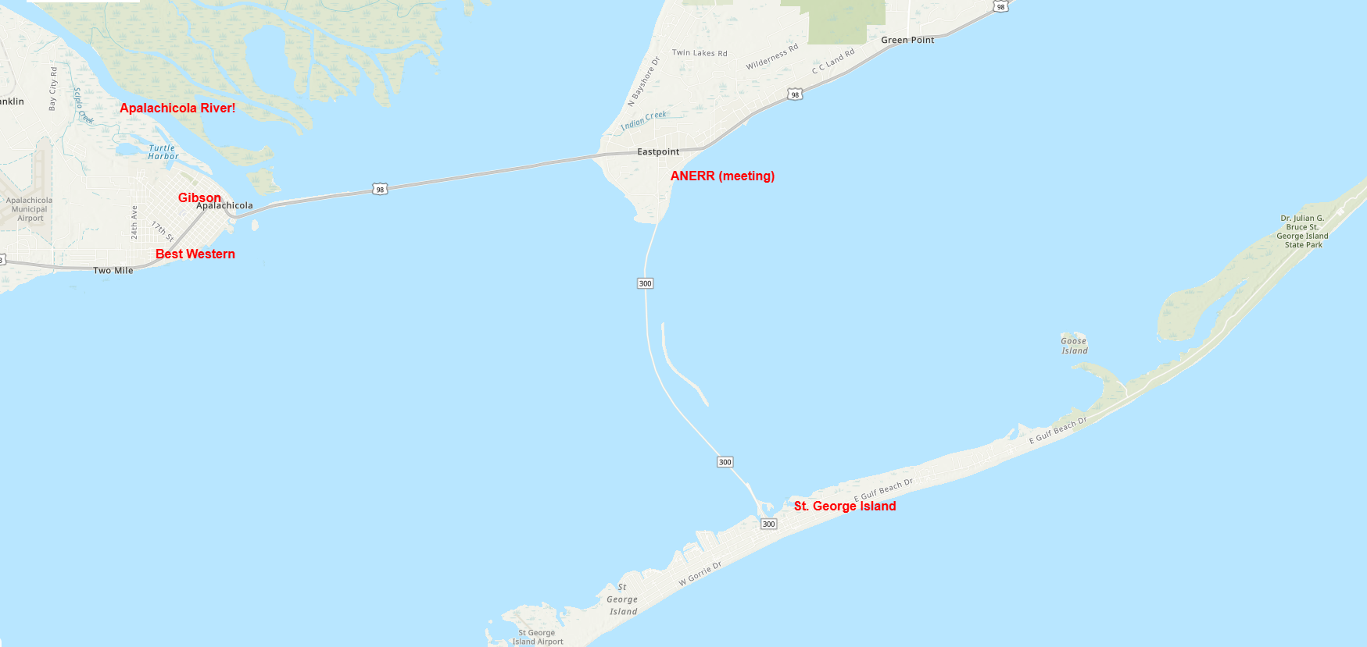

Field Trip Information

Tour of Florida State University Coastal and Marine Laboratory FSU Coastal and Marine Laboratory

“The FSU Coastal and Marine Lab is a leader in conducting and supporting exceptional research that advances marine ecosystem science and conservation. Citizen Science Programs are also an important part of the FSUCML vision to engage the public in science and nature while protecting the rich biodiversity surrounding the lab.”

We will have a tour of the lab and the surrounding area, including a boat outing. The marine lab is an approximately 40 minute drive from the ANERR. Please carpool as much as possible as parking may be limited.

FSU Coastal and Marine Laboratory
3618 US Highway 98 E
St. Teresa, Florida

1:30pm - 1:45pm: Arrive at FSUCML and Check in
1:45pm - 2:00pm: Welcome talk
2:00pm - 3:15pm: Boat outing 1 & 2/Lab Tour
3:15pm - 4:30pm: Boat outing 3 & 4/Lab Tour
4:45pm: Depart FSUCML

Abstracts

ANERR Welcome and Overview
Apalachicola National Estuarine Research Reserve: Introduction and Research Overview
Megan Lamb
Assistant Manager and Research Coordinator, Apalachicola National Estuarine Research Reserve

Megan will give an overview of the meeting’s host facilities program, including the National Estuarine Research Reserve (NERR) System, its co-management by the Florida Department of Environmental Protection and the National Oceanic and Atmospheric Administration, and Reserve component programs. Information will include the significance of the Apalachicola watershed and its uniqueness and biodiversity which has led to multiple management designations. The presentation will include more in-depth description of the Reserve’s research programs with emphasis on the System-Wide Monitoring Program, a NERRs-wide program that includes long-term, high quality water quality monitoring, nutrient and chlorophyll monitoring, and weather information.

Session 1: Harmful Algal Blooms and Response
Florida DEP Freshwater Harmful Algal Bloom Response
Cheryl Swanson
Program Administrator
Laboratory – Biology Program
Florida Department of Environmental Protection
The Florida Department of Environmental Protection (DEP) oversees freshwater algal bloom response and analysis. DEP reviews reports of blooms observed during routine sampling or received from citizens via an online reporting form or hotline. DEP then prioritizes and coordinates with water management districts, state agencies and local governments to respond based on location, potential for human exposure, and sampling schedules. Site visit information and laboratory results are posted to the DEP Algal Bloom Dashboard. The Florida Department of Health (DOH) is the lead agency for public health and oversees public health notifications as deemed appropriate for recreational waters where there is a risk of the public coming into contact with an existing algal bloom. The Protecting Florida Together Water Quality Dashboard compiles and delivers relevant water quality information statewide including blue-green algae, red tide and nutrient monitoring data.
The Use of FlowCam Technology in Algal Monitoring

Vicki McGee
Environmental Specialist II
Biology Section
Florida Department of Environmental Protection

Chelsea Lam
Environmental Consultant
Biology Section
Florida Department of Environmental Protection

The Florida Department of Environmental Protection receives and analyzes algal samples for microscope analysis from lakes, canals and waterbodies throughout Florida. Recently, the laboratory acquired a FlowCam instrument to support increased volume of algal bloom samples. The instrument uses flow imaging cytometry to collect thousands of images of a single sample and sort the images that are cyanobacteria based on fluorescence. This presentation highlights the FlowCam method development, advantages and difficulties of this technique. We will also discuss examples of data collected to demonstrate FlowCam’s potential applications in algal bloom monitoring.

Building Tennessee’s HABs Response Program: Lessons, Challenges, and Progress
Jessica Rader
HABs Response Coordinator, Tennessee Dept. of Environment and Conservation

Harmful algal blooms (HABs) have emerged as a recurring challenge for Tennessee’s waters, threatening drinking water supplies, recreation, aquatic life, and public health. In response, Tennessee’s Department of Environment and Conservation has worked over the past two years to build a coordinated statewide HAB program. This presentation outlines the program’s development, including the establishment of interagency partnerships, field response protocols, and public communication tools. Emphasis will be placed on lessons learned during the program’s early years, such as the importance of rapid toxin screening, consistent reporting pathways, and collaboration between environmental and health agencies. Key successes, including improved incident tracking and strengthened field response capacity, will be highlighted alongside remaining challenges.
HAB Regional Discussion
Seth McWhorter
Water Quality Standards Coordinator
Harmful Algal Blooms Region 4 Contact
US EPA Region 4 Water Division

Seth will moderate a state and EPA discussion of HAB response efforts, including challenges and achievements.
Session 2: New Approaches and Innovative Technologies
Springs Monitoring of Submersed Aquatic Vegetation – Moving Forward With New Technology

Jodi B. Slater
Environmental Scientist IV
Bureau of Environmental Sciences
Division of Water Resources
St. Johns River Water Management District

St. Johns River Water Management District (SJRWMD) has monitored seven major 1st and 2nd Magnitude springs in their area since 2008 and added another spring this past year (total eight). Previous methods were time and labor intensive but did not allow for a full change analysis over time to track springs changes in submerged aquatic vegetation (SAV), algae, native and invasive flora or fauna, and impacts from erosion, recreational activities, etc. In 2024, monitoring methods were streamlined to more efficiently collect comprehensive data at the same transect sites as previous years. Methods were evaluated that would allow for a visual, archivable, GIS based mapping survey that can be conducted regularly to determine presence and abundance of SAV, algae, flora/fauna, as well as to determine areas of sensitivity or impacts. In 2025, the Wekiva Wild & Scenic River Committee conducted a survey of the Wekiva River System to map SAV using Trutta Environmental Services’ High-Definition Stream Survey (HDSS) method. The SJRWMD used this project as a pilot to justify moving forward with a similar technological mapping survey for future springs monitoring and mapping, starting in 2026.

High Definition Stream Survey (HDSS): Addressing Water Quality Challenges in the Hurricane Creek Watershed

Brett Connell
Hydrologist
Trutta Environmental Solutions

The High Definition Stream Survey (HDSS) is being used to address complex water quality issues across the 250-mile Hurricane Creek watershed in central Alabama. Funded through the Abandoned Mine Land Economic Reclamation (AMLER) Program, the project prioritizes streams for reclamation by collecting continuous, 1-meter resolution GIS data in a single survey pass. Integrating GPS, video, depth, side-scan sonar, and water quality sensors, HDSS creates a georeferenced, high-resolution baseline inventory for precise stream segment selection and prioritization.
This presentation highlights HDSS fieldwork and shows how the data guides cost-effective mitigation, maps instream habitat, assess geomorphic conditions, identify infrastructure impacts and provides the ability to monitor restoration progress. The approach also provides an interactive virtual tour to support stakeholder collaboration and decision-making. The Hurricane Creek project demonstrates how HDSS can be scaled to address water resource challenges in other historically impacted watersheds.

Reference Trend Network (Including SEMN): Preliminary Analysis

David Smith
Kentucky Division of Water
Water Quality Branch – Monitoring Section

The Kentucky Division of Water established the Reference Trend Network in 2013 to evaluate long-term trends in stream water quality. The network consists of 16 reference streams statewide, including four from the Mountain bioregion that are also part of the Southeastern Monitoring Network (SEMN), an interstate monitoring initiative. We have now collected over a decade of data from these 16 sites. This data had primarily been used for water quality assessments until an in-depth analysis began this year.
Our initial analysis focuses on changes in macroinvertebrate assemblages and associated environmental variables. Laurel Creek, one of the SEMN sites, was selected as a case study to develop methods for assessing all sites. Non-metric multidimensional scaling (NMDS) based on Bray–Curtis dissimilarity at the genus level revealed that three of nine years differed from the overall assemblage pattern. Canonical Correspondence Analysis (CCA) with forward stepwise model selection was then used to explore relationships between assemblage structure and environmental variables. Although the CCA and forward selection were not statistically significant, Julian day (sampling date) showed the strongest correlation with assemblage structure. Two of the three deviant years were sampled in early April rather than early May, suggesting that seasonal timing contributed to assemblage differences. The third deviant year lacked a strong environmental signal, but further inspection indicated its distinctiveness was driven by unusually high abundances of midge larvae.
These findings highlight the value of long-term reference trend sites, where stable conditions reduce background variability and allow subtle ecological changes to be detected. Challenges encountered during this analysis and future directions for the full trend network dataset will be discussed.

5 Year Trends from Kentucky’s Statewide Probabilistic Stream Monitoring Program

Sara Craft
Environmental Biologist II
Kentucky Division of Water, WQB

The Kentucky Probabilistic Stream Monitoring Program has collected habitat, water chemistry, and biological samples in various forms since 1998. Since 2017, sampling has been conducted on a statewide basis. Recently, data from statewide sampling (n = 50 sites annually) were compiled for the 2017-2022 project years and uploaded to EPA’s ATTAINS database. For the first time in the program’s history, Kentucky’s Probabilistic raw data have been extrapolated to total state stream mile estimates of condition and shared with the public. This presentation details how data were processed and uploaded to ATTAINS, which tools were used to summarize data, and other capabilities of related EPA tools. A brief overview of habitat, macroinvertebrate, and fish extrapolated results revealed dominance of Poor habitat scores, normal distribution of macroinvertebrate index scores, and overall lack of relationship among metric scores at individual sites sampled. Future directions for this project include addition of 2023 and 2024 data, analysis of component metrics, and addition of historical non-statewide program data in ATTAINS.

Blackwater Streams Project Update

David Chestnut
Senior Scientist, Surface Water Monitoring
Aquatic Resource Monitoring Section
Aquatic Science Division
Bureau of Water
S.C. Department of Environmental Services

In 2022 EPA Headquarters expressed interest in developing an operational definition of blackwaters and a classification system that recognizes generalized types for the purposes of future NARS Rivers and Streams assessments. They recognized that in association there was potentially a need for new water quality criteria protective of these unique systems and the development of data-driven, consistent, and repeatable use attainment assessment methods. Joe Flotemersch, EPA Office of Research and Development, Cincinnati, OH, was given the lead on this effort. Subsequently he had discussion with many States, leading to the publication of Flotemersch, J. 2022. Conservation of blackwater rivers and streams of the coastal plains of United States: Knowledge and research needs. Ambio. 52, 665-677. https://doi.org/10.1007/s13280-022-01818-9 The South Carolina Department of Environmental Services (then SC Dept. of Health and Environmental Control, SCDHEC) volunteered to serve as a pilot project State to advance the effort. This presentation will present a summary of the results of several different studies, conducted by several different South Carolina and EPA entities, including dissolved organic carbon and absorbance measures as a potential identifier, and next steps.

Blackwater Stream Dwellers
Justin Lewandowski
S.C. Department of Environmental Services

Due to their lower gradients and high swamp drainages, blackwater streams tend to have unique characteristics such as naturally low dissolved oxygen and pH levels. Reflected in this are aquatic biota adapted to these conditions. Among these are unique taxa and assemblages of fish and macroinvertebrates which can help to further characterize blackwater systems.

Session 3: Extreme Weather Events--Monitoring

Hurricane Helene Effects on Benthic Macroinvertebrates of 11 North Carolina Streams
David Harwood
Biological Technician
Benthic Assessment Branch
North Carolina Department of Environmental Quality

The North Carolina Benthic Assessment Branch (BAB) sampled 11 reference streams in three different river basins (Broad, Catawba, and French Broad) directly following the catastrophic flooding caused by Hurricane Helene. These sites were chosen for their historical benthic assessment data, were of Good or Excellent water quality, and were among those safely accessible. The EPT collection method was used at all sites; this method includes collecting insects in the orders Ephemeroptera, Plecoptera, and Trichoptera, preserving them, and bringing them back to the lab for identification to the lowest taxonomic order. The richness and abundance of these insects were then compared to previous benthic data to better understand Hurricane Helene’s impact on macroinvertebrates. Biologists returned to the most negatively impacted of these sites in the summer and fall of 2025 to determine if the abundance and richness of EPT species had improved compared to the data collected directly Post-Helene.
Hurricane Helene: Impacts and Recovery in Tennessee

Shawn R. Puckett, Assistant Director
TDEC Office of Emergency Management
Cookeville Environmental Field Office

Although Hurricane Helene made landfall far from Tennessee, the storm’s far-reaching inland impacts presented significant challenges in East Tennessee. As Helene moved inland in late September 2024, Tennessee experienced record rainfall, flash flooding, landslides, and widespread infrastructure disruptions.
At the height of the crisis, telecommunications services in the affected areas were down for several days, widespread power outages occurred, and numerous state and local roads were closed. Critical water infrastructure also sustained damage, impacting multiple drinking water systems and wastewater treatment plants. A water contact advisory was issued on November 25th, 2024, due to contamination concerns and remained in place until January 15th, 2025. Recovery operations included the removal of more than 5.3 million cubic yards of waterway debris across affected areas.
In recognition of the extraordinary efforts made during the response, many first responders — including TDEC’s Office of Emergency Management — were honored with a signed Senate Joint Resolution acknowledging the individuals, organizations, and agencies that came to the aid of their fellow citizens during Hurricane Helene. TDEC Environmental Responder Tina Robinson was personally recognized on the Senate floor, while numerous other TDEC Emergency Coordinators were honored from the Senate gallery during the proceedings. Tina was also awarded the Governor’s Excellence in Service Award in February 2025.
This presentation highlights both the widespread impact of Hurricane Helene on Tennessee’s infrastructure and environment, and the collaborative multi-agency response that followed. It emphasizes the increasing importance of disaster preparedness in inland regions facing the growing threat of severe weather systems.

Hurricane Impacts Along the Springs Coast (FL)

Madison Trowbridge, Ph.D.
Springs Scientist
Surface Water Improvement & Management (SWIM) Section
Southwest Florida Water Management District (SWFWMD)

The Springs Coast region of west-central Florida is home to five first-magnitude spring groups: Rainbow, Chassahowitzka, Homosassa, Weeki Wachee, and Crystal River/Kings Bay. For the coastal spring systems, salinity variation is a major ecological driver. Recent hurricanes, including Hurricanes Idalia (2023) and Helene (2024) brought saline water to tidal, freshwater habitats in these springs during storm surge inundation. The Southwest Florida Water Management District (SWFWMD) captured significant ecological shifts following these storms.

Session 4: Ecological Restoration and Invasive Species Management
Restoration of Crooked Creek after Dam Removal
Nia Wellendorf
Program Administrator
Water Quality Standards Program
Florida Department of Environmental Protection

Florida DEP biologists monitored water chemistry and in-stream biological condition of Crooked Creek in north Florida following the removal of an earthen dam in Fall 2022. Immediately after dam removal, concentrations of turbidity, nutrients, and lead below the former dam were higher than upstream or downstream concentrations. However, concentrations fell to typical levels within one year after the dam removal. The in-stream macroinvertebrate community immediately below the dam was depauperate before dam removal but recovered to healthy levels two years after dam removal.

Spearfishing Invasive Exotic Armored Catfish at Blue Spring State Park
Kathryn March
Environmental Consultant
Watershed Monitoring Section, Division of Environmental Assessment and Restoration
Florida Department of Environmental Protection

The armored catfish (Pterygoplichthys sp.) is an exotic invasive species in Florida, originally from Central and South America and introduced to Florida through the aquarium trade. Armored catfish have become prolific in Florida waterbodies due to their ability to live in nearly any conditions and to outcompete native species. Their presence is linked to multiple ecological concerns such as bank destabilization, disruption of native flora and fauna, and even driving manatees out of their warm-water sanctuaries in the winter. Staff from DEAR’s Central Regional Operation Center in Orlando participate in armored catfish removal at Blue Spring State Park in Volusia County with park staff in an attempt to control their numbers and minimize their impacts to the spring run.
All Hands-on Deck: Community-Driven Restoration in Choctawhatchee Bay
Kayla Wingard
Monitoring Program Manager
Choctawhatchee Basin Alliance

This presentation highlights the role of community collaboration in advancing habitat restoration projects in Choctawhatchee Bay, Florida. The Choctawhatchee Basin Alliance (CBA) works alongside local residents, schools, and partner organizations to implement projects that restore critical coastal habitats, including oyster reefs, living shorelines, and seagrass beds. Community members get involved in various stages of the projects, from identifying restoration needs in their neighborhoods to cultivating plants and oysters in classrooms and contributing the physical labor required for project installation.
CBA’s programs demonstrate the power of community-driven restoration. Homeowners and businesses contribute to oyster gardening efforts that enhance water quality and habitat. Elementary students grow shoreline plants in school-based nurseries, which are later transplanted into living shorelines, while high school students propagate seagrass to help address stormwater impacts. These projects integrate restoration into education and civic engagement, and vice versa, fostering environmentally educated citizens who are empowered to continue to advocate and protect their natural resources.

Session 5: Special Projects in Biological Assessment and State Updates
An Algae and Macrophyte Survey Pilot Project for Springs in Florida
Ashley O’Neal
Environmental Consultant
Aquatic Ecology and Quality Assurance Section
Florida Department of Environmental Protection

The Florida Department of Environmental Protection (DEP) is exploring options for biological assessment in spring systems, to support Basin Management Action Plan (BMAP) monitoring objectives. DEP has conducted an initial, small-scale survey of submersed vascular plants, attached algae, and algal mats in spring runs using both DEP and SJRWMD protocols to determine which methods are practical and effective for indicating biological impairment as well as improvement in spring systems.

Florida DEP Reference Stream Sampling Project
Joy Jackson
Environmental Manager
Aquatic Ecology and Quality Assurance Section
Florida Department of Environmental Protection

The Florida Department of Environmental Protection (DEP) has been sampling reference streams since the early 1990’s. These data have been used in many capacities including the development and refinement of stream bioassessment tools, founding biological integrity criteria, and establishing and interpreting numeric nutrient criteria. DEP reinstated a reference stream project in 2015 to re-evaluate historic reference streams, document changes in the conditions, and to routinely sample a revised list of reference streams. The current list of sites includes 56 sites throughout Florida typically score in the “Exceptional” or “Healthy” Stream Condition Index (SCI) categories for biological health.
Environmental Stressors of Southeastern US Stream Fish Communities: an Integrated Modeling Approach Using Water Quality, Habitat, and Landscape Predictors

Justin C. Bagley ^{1,2,3,*} · Patrick E. O’Neil ⁴ · Elizabeth S. Huff ¹
¹ Environmental Indicators Section, Field Operations Division, Alabama Department of Environmental Management, P.O. Box 301463, Montgomery, AL 36130, USA
² Department of Biology and Environmental Sciences, Auburn University at Montgomery, 7061 Senators Dr., Rm. 209 O GH, Montgomery, AL 36117, USA
³ Department of Biology, Virginia Commonwealth University, 1000 W Cary St., Suite 126, Richmond, VA 23284, USA
⁴ Geological Survey of Alabama, Walter B. Jones Hall, 420 Hackberry Lane, Tuscaloosa, AL 35487, USA (retired)

Multiple stressors threaten the biological diversity and ecological services provided by freshwater ecosystems, yet understanding biological responses to these stressors remains a key and understudied challenge for water resource managers. We investigated the relative importance of water quality, habitat, and landscape-scale stressors potentially mediating fish community condition [i.e., fish index of biotic integrity (FIBI) scores and condition ratings] at 490 stream sites across Alabama. A large environmental dataset (101 predictors) was reduced to 18 predictor variables including water quality (temperature, dissolved oxygen, pH, chlorides, specific conductance, turbidity), nutrient enrichment (total nitrogen, total phosphorus, etc.), instream habitat quality and substrate (cobble, organic matter) variables, as well as orthogonal axes reflecting catchment-scale, land use-land cover variables. Multivariate regression and machine-learning analyses were conducted on FIBI outcomes (after residualizing out effects of ichthyoregion and drainage area) using a consensus-vote approach comparing results from three algorithms—partial least squares regression, elastic net regression, and random forest. Results for two tracks (with vs. without missing data imputation) were largely congruent across methods and revealed that chlorides and instream habitat variables (organic matter, instream habitat quality) were the most important predictors. Partial effects on FIBI scores increased with increasing habitat quality, organic matter, and dissolved oxygen but decreased at higher chloride and total nitrogen concentrations, which suggests that fish community condition has responded to stress induced by anthropogenic habitat degradation and chloride inputs from natural and anthropogenic sources (e.g., rock weathering, wastewater treatment facilities). Our results add to a growing body of evidence that field-based monitoring data can inform which stressors and environmental impacts drive changes in the biotic integrity of freshwater ecosystems.

Attendee Contact List

United States Environmental Protection Agency

Seth McWhorter
McWhorter.Seth@epa.gov

Alabama Department of Environmental Management

Justin Bagley, PhD.
justin.bagley@adem.alabama.gov

Lisa Huff
ESH@adem.alabama.gov

Eastern Band of Cherokee Indians

Rainee Tetreault
raintetr@ebci-nsn.gov
Florida Department of Environmental Protection

Frank Butera (NW ROC)
Frank.Butera@FloridaDEP.gov

Alicia Cedeño-Salgado
Alicia.M.Cedenosalgado@floridadep.gov

Kyle Coker (NE ROC)
Kyle.Coker@FloridaDEP.gov

Rachael Dragon (WQMP)
Rachael.Dragon@FloridaDEP.gov

Josh Farre
Joshua.Farre@FloridaDEP.gov

Joy Jackson (AEQA)
Joy.Jackson@FloridaDEP.gov

Monica Jaeger (SROC)
Monica.Jaeger@FloridaDEP.gov

Chelsea Lam (Biology)
Chelsea.Lam@FloridaDEP.gov

Megan Lamb (ANERR)
Megan.Lamb@FloridaDEP.gov

Aaryn Letson (AEQA)
Aaryn.Letson@FloridaDEP.gov

Kathryn March (CE ROC)
kathryn.w.march@FloridaDEP.gov

Vicki McGee-Absten
Vicki.McGee@FloridaDEP.gov

Ashley O’Neal (AEQA)
Ashley.ONeal@FloridaDEP.gov

Amelia Rankin (Biology)
Amelia.Rankin@FloridaDEP.gov

Todd Risk (Biology)
Todd.Risk@FloridaDEP.gov

Cheryl Swanson (Biology)
Cheryl.Swanson@FloridaDEP.gov

Nia Wellendorf (WQSP)
Nijole.Wellendorf@FloridaDEP.gov

Kentucky Department for Environmental Protection –
Division of Water

David Smith
DavidS.Smith@ky.gov

Sara Craft
sara.craft@ky.gov

Mississippi Department of Environmental Quality

Melody Chimahusky
mchimahusky@mdeq.ms.gov

Carlee Shuler
cshuler@mdeq.ms.gov

North Carolina Department of Environmental Quality

David Harwood
David.Harwood@deq.nc.gov

Eric Fleek
Eric.Fleek@deq.nc.gov

South Carolina Department of Environmental Services

David Eargle
eargleda@dhec.sc.gov

Riley Eldridge

David Chestnut
david.chestnut@des.sc.gov

riley.eldridge@des.sc.gov

Victoria Ferri
victoria.ferri@des.sc.gov

Chip Howenstine
Charles.howenstine@des.sc.gov

Courtney Kemmer
Courtney.Kemmer@des.sc.gov

Justin Lewandowski

lewandjf@dhec.sc.gov

Tennessee Department of Environment and Conservation –
Division of Water Resources

Nicholas Bolin

Nicholas.Bolin@tn.gov

Beverly Brown
Beverly.Brown@tn.gov

Casey Choate
Casey.Choate@tn.gov

Franklin Colyer
Franklin.Colyer@tn.gov

Luke Dotson
Luke.dotson@tn.gov

Josh Frazier
Joshua.frazier@tn.gov

Amy Fritz
Amy.fritz@tn.gov

Kim Laster
Kim.laster@tn.gov

Clay Mahan
Clayton.Mahan@tn.gov

Brian Plante
Brian.Plante@tn.gov

Shawn Puckett
shawn.puckett@tn.gov

Jessica Rader
jessica.rader@tn.gov

James Roberts
James.roberts@tn.gov

Tina Robinson
Tina.A.Robinson@tn.gov

Renee Rodriguez
Renee.rodriguez@tn.gov

Tayler Rutherford
Tayler.Rutherford@tn.gov

Lilia Sewell
Lillia.Sewell@tn.gov

Quinten Tolliver
quinten.tolliver@tn.gov

Chip Walton
Charles.walton@tn.gov

Claire Williams (TN Dept. of Health) Claire.williams@tn.gov

Invited Speakers and Participants from Other Organizations

Brett Connell, Trutta Solutions
brett.connell@truttasolutions.com

Madison Trowbridge, PhD. Southwest Florida Water Management District
Madison.Trowbridge@swfwmd.state.fl.us

Jodi Slater, St. Johns River Water Management District
JSlater@sjrwmd.com

Kayla Wingard, Choctawhatchee Basin Alliance
wingardk@nwfsc.edu

Jon Michael Mollish, Tennessee Valley Authority
mmollish@tva.gov

Justin Wolbert, Tennessee Valley Authority
jrwolbert@tva.gov

