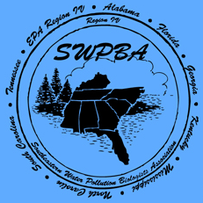
Southeastern Water Pollution Biologists Association Annual Meeting
Monday, October 6th – Thursday, October 9th, 2025
Apalachicola National Estuarine Research Reserve (ANERR) Eastpoint, FL
$150.00 Registration Includes
- Admittance to meeting
- Macroinvertebrate Workshop (Monday, October 6th, 1:00 – 4:30 PM, see below for more information)
- Field Trip to Florida State University Coastal and Marine Lab, St. Teresa, FL (Wednesday October 8th, 1:00-4:30 plus travel time)
Other Registration Options
- T-Shirt - $20.00
- Single day registration - $50.00
Please fill out the following section and submit by September 1st by emailing to Ashley O’Neal at Ashley.Oneal@FloridaDEP.gov Please pay t shirt orders in advance via PayPal. Registration may be paid in advance or upon arrival. PayPal is preferred. Checks accepted only on arrival.

Name: | Ashley O Neil
Agency: | Department of Environmental Protection – Division of Environmental Assessment and Restoration
Email Address: | Ashley.Oneil@FloridaDEP.gov
Phone: | 850-245-8195
 | Cost | Additional Information | Total
Main Meeting | $150.00
Invert Workshop | Included |  | Y/N
Field trip to FSUCML | Included |  | Y/N
 |  | Fit:
 |  | T-Shirt Size (S-2XL): | L
 |  | Quantity: | 1
T-Shirt | $20.00
Single Day | $50.00 | Day:
Grand Total |  |  | $170

