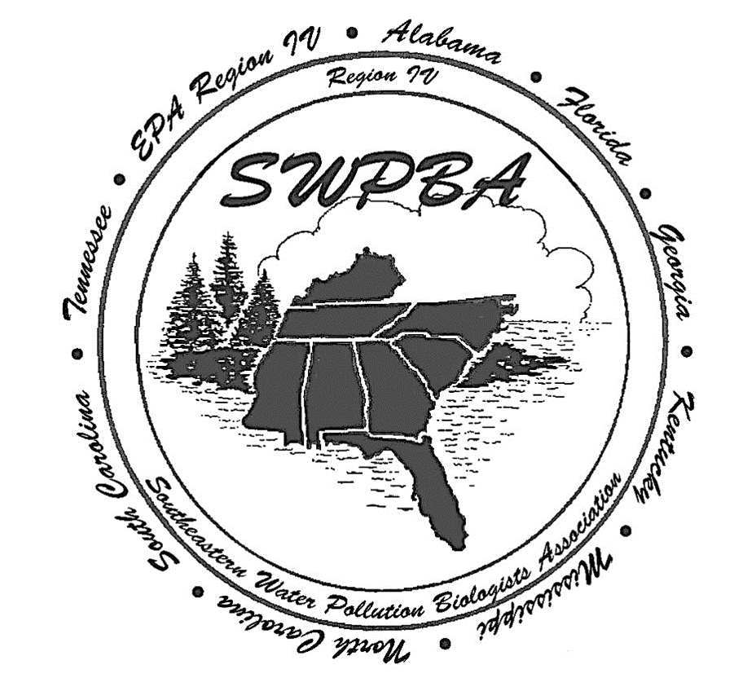
Southeastern Water Pollution Biologist Association
53rd Annual Meeting
Gatlinburg, TN
October 19th to October 22nd, 2026

DAY 1: MONDAY, OCTOBER 19TH
Time | Event / Topic | Location / Details
9:30 AM – 11:00 AM | Registration | Hotel Conference Room
 | Field Trip #1 (Starts) | Meet in Hotel Lobby
12:00 PM – 4:30 PM | [CHOOSE ONE CONCURRENT OPTION]
12:00 PM – 4:30 PM | - Option A: Field Trip #1 | Noland Divid Monitoring Station
1:00 PM – 4:30 PM | - Option B: Workshop #1 | Hotel Conference Room
6:00 PM – 7:30 PM | Registration & Hospitality Social | Hotel Lounge / Designated Area
DAY 2: TUESDAY, OCTOBER 20TH
Time | Event / Topic | Location / Details
7:30 AM – 8:30 AM | Registration | Hotel Lobby
8:30 AM – 9:00 AM | Opening Remarks & Meeting Start | April Grippo, Director (TDEC - Division of Water Resources)
9:00 AM – 10:00 AM | Session #1: Monitoring Throughout the Southeast | Hotel Conference Room
10:00 AM – 10:15 AM | Morning Break | Refreshment Station
10:15 AM – 11:30 AM | Session #2: All HABs (Harmful Algal Blooms) | Hotel Conference Room
11:30 AM – 1:15 PM | [CHOOSE ONE LUNCH OPTION]
 | - Option A: Lunch on Your Own | Off-site
 | - Option B: SEMN Lunch Workshop | Hotel Conference Room (Participating Orgs Only)
1:15 PM – 2:15 PM | Session #3: Nutrients in the Southeast | Hotel Conference Room
2:15 PM – 2:30 PM | Afternoon Break | Refreshment Station
2:30 PM – 3:30 PM | State, EPA, & Tribal Updates + Q&A | Reps from each State, EPA Region IV, & Tribes
3:30 PM – 3:45 PM | Quick Break | Refreshment Station
3:45 PM – 4:30 PM | Session #4: Data Capture | Hotel Conference Room
4:30 PM – 5:00 PM | SWPBA Business Meeting | All Members Welcome
7:30 PM – 9:00 PM | SWPBA Trivia Night | Hotel Conference Room
DAY 3: WEDNESDAY, OCTOBER 21ST
Time | Event / Topic | Location / Details
7:30 AM – 8:30 AM | Registration | Hotel Lobby
8:30 AM – 10:00 AM | Session #5: Success Stories | Hotel Conference Room
10:00 AM – 10:15 AM | Morning Break | Refreshment Station
10:15 AM – 11:00 AM | Session #6: Nutrients, Diatoms, and Aquatic Life | Hotel Conference Room
11:00 AM – 11:15 AM | Quick Break | Refreshment Station
11:15 AM – 12:00 PM | Session #7: Citizen Science | Hotel Conference Room
12:00 PM – 1:30 PM | Lunch and learn | Provided on-site
1:30 PM – 2:00 PM | Transit Window / Free Time | Prepare for afternoon tracks
2:00 PM – 4:30 PM | [CHOOSE ONE CONCURRENT OPTION]
 | - Option A: Field Trip #2 | Behind-the-Scenes: Ripley’s Aquarium of the Smokies
 | - Option B: Workshop #2 | Hotel Conference Room
5:00 PM – 9:00 PM | Banquet and Awards Ceremony | TBD
DAY 4: THURSDAY, OCTOBER 22ND
Time | Event / Topic | Location / Details
9:00 AM – 10:00 AM | Session #8: The "Potpourri" Session | Hotel Conference Room
10:00 AM – 10:15 AM | Final Break | Refreshment Station
10:15 AM – 11:00 AM | Session #9: Wetlands and ARAP | Hotel Conference Room
11:00 AM | SWPBA 53rd Annual Meeting Adjourns | Safe travels home!

