53rd Annual Southeastern Water Pollution Biologists Association Conference
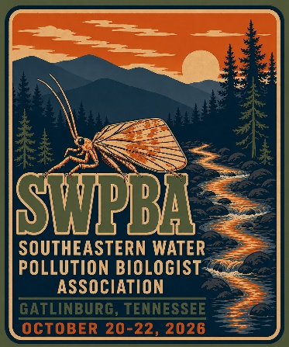
Monday, October 19th - Thursday October 22nd, 2026
$150.00 Registration Includes (By September 25th)
- Admittance to conference
- Workshop or Field Trip (Monday October 19th)
- Ripley Aquarium of the Smokies behind the scenes tour
- Workshop (Wednesday October 21st)
- Banquet
Other Registration Options
- T-Shirt - $20.00 (By September 25th)
- Late Registration (By October 2nd) - $190.00
- Single day registration (does not include banquet ticket) - $50.00

Please fill out the following section: registration, Monday Workshop/Field Trip, T-shirt order, Wednesday Workshop/Aquarium, and submit by September 25th by emailing to Chip Walton @ swpbapresident@gmail.com (We cannot guarantee T shirt for attendees registering after October 2nd). Registration may be paid in advance or upon arrival. PayPal is preferred and links are below. Advance payments by checks should be made out to SWPBA and mailed to SWPBA President Charles Walton, 1301 Riverfront Parkway, Suite 206, Chattanooga, TN 37402. No Cash.
Name:
Agency:
Email:
Phone:
 | Cost | Additional Information | Total
Main Conference | $150.00
Late Main Conference | $190.00
Single Day | $50.00 | Day:
Extra Banquet Ticket | $75.00 | Quantity:
T-Shirt | $20.00 | Quantity:
Sizes: S, M, L, XL, 2XL, 3XL, or 4XL |  | Bella Canvas Tri blend (Sizes and Qty):
Sizes: S, M, L, or XL |  | Women’s Boxy Tee (Sizes and Qty):
Comments or Questions:
Grand Total
Pay upon arrival (Yes or No)
Advance payment (Yes or No)

Registration PayPal Payment Link
https://www.paypal.com/ncp/payment/A8XAQU5A6HPAA

T-Shirt PayPal Payment Link
https://www.paypal.com/ncp/payment/E46BKR8RBU54E

Are you planning to attend the field trip on Monday October 19th? (See 3rd page for details)
YES
NO
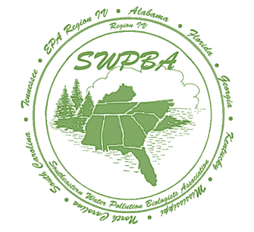
Are you planning to attend the EPT workshop on Monday October 19th? (See 4th page for details)
YES
NO

Banquet information: TBD Wednesday October 21st.

Indicate dietary restrictions, if any:

Wednesday October 21st afternoon will have two options of activities to do in Gatlinburg starting at around 2:00pm until 4:30pm. Which activity would you like to attend?
YES or NO
Ripley Aquarium of the Smokies behind the scenes tour
Taxonomy Fair
Nothing? (Free)

Important Dates
September 19th, 2026
Hotel Reservations (cannot guarantee conference rate after this date)

September 25th, 2026
Registration Form
T-shirt Order Form
Workshop Registration
Wednesday Afternoon Gatlinburg Activities Registration
Biologist of the Year Nominations
Lifetime Achievement Award Nominations

October 2nd
Late Registration Form
Workshop Registration
Wednesday Afternoon Gatlinburg Activities Registration
Presentation Title
State/Tribe/EPA Newsletter Items

October 16th
Submit photo digitally for inclusion in photo contest (categories announced soon)

Hotel information is below

Conference Lodging Information:
- Edgewater Hotel and Conference Center
- Reservations must be made by Saturday, September 19, 2026, to guarantee the conference rate
- Conference rate: $110 + tax + $15 daily parking
- Parking garage clearance: 6 ft 6 in, call ahead if this is an issue
- Breakfast included
- Each room includes a mini fridge, microwave, and coffee maker
- Reservations must be made by phone; mention SWPBA to receive the conference rate
- Phone: 865-436-4151
- A credit card is required to reserve but will not be charged until arrival
- Cancellations must be made at least 72 hours prior to arrival
- Hotel website: https://edgewater-hotel.com/

Airport Information
- Plan on getting a rental car because Lift or Uber would be very expensive to get to Gatlinburg from either airport.

McGhee Tyson Airport in Knoxville, TN (approximately 41 miles away from Gatlinburg)
- https://flyknoxville.com/

Tri-Cities Airport in Blountville, TN (approximately 102 miles away from Gatlinburg)
- https://flytri.com/

Field Trip to Noland Divide Research Site on Monday, October 19th
(12:00pm to 4:30pm)
- Meet at Edgewater Hotel Lobby at 12:00pm (eastern time)
- Carpool to Research Site

In the Great Smoky Mountains National Park (GRSM), the Noland Divide watershed (NDW) high-elevation monitoring station has been in operation since 1991. The monitoring site was constructed in 1991 by Oak Ridge National Laboratory as part of an international study, the Integrated Forest Study to study the effects of acid deposition on forests in North American and Europe. NDW is located downgradient about 2 km of Kuwohi (Clingman’s) Dome (Figure 1). The monitoring site consists of: 1) the open site (OS) which houses a full weather station, rain gauges, and automated wet deposition collector; 2) the throughfall (TF) deposition collection site which has 12 deposition collections, soil moisture and air temperature probes, and soil vacuum lysimeter pit collecting soil water at O/A, B, and C soil horizons; and 3) the SW and NE stream stations which has 3-foot H-flumes with continuous stage recorders for flow measurements, passive siphon samplers, and water quality sondes for pH, conductivity and temperature. Since 1991 to the present, water quality samples have been collected biweekly at the SW/NE streams, wet and TF deposition collectors, and monthly at the soil lysimeter station. The extensive data set on precipitation, soil, and stream water at this high-elevation monitoring station has provided valuable information on the effects of acid deposition on soil and stream water quality. In addition to the long-term shifts in biogeochemical processes as these Appalachian Forest ecosystem continue to recover from improved air quality, as a result of the federal Clean Air Act Amendments of 1990, and locally GRSM the construction of air pollution equipment at the Kingston and Bull Run coal-fired power plants.
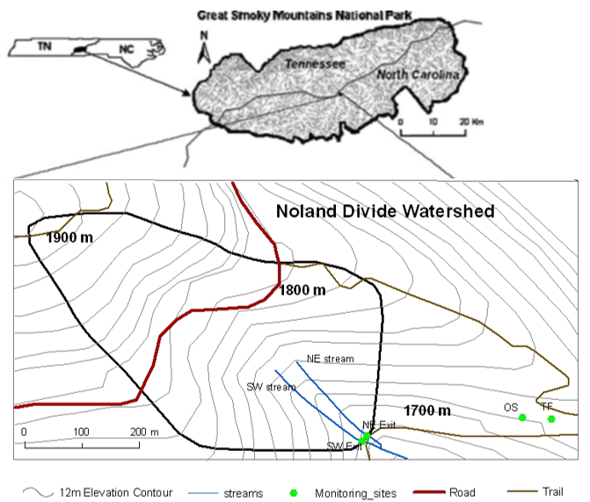
EPT Workshop with Dr. Jason Robinson on Monday, October 19th
(12:00pm to 4:30pm)
- Meet at Edgewater Hotel Confrence Room at 12:00pm (eastern time)

This workshop is designed as a refresher course for those who have been seeking certification or recertification on the identification of eastern EPT genera. We will go through the characters required to separate the taxa that are on the suggested study list and also discuss problem taxa that show up in monitoring samples. Participants are encouraged to bring specimens and their identification literature. Please bring your own microscope if you are able. Jason will have a limited number of microscopes.

“Taxonomy Fair” with Dr. Jason Robinson on Wednesday, October 21st
(1:30pm to 2:45pm)
- Meet at Edgewater Hotel Confrence Room at 1:30pm (eastern time)

Stumped by a specimen? Bring your mysteries to the Taxonomy Fair! This interactive, hands-on session is your chance to get expert identification assistance with challenging aquatic macroinvertebrates. Attendees are encouraged to bring their own preserved specimens. Whether it is a tricky caddisfly larva, an elusive stonefly, or an unfamiliar mayfly, Dr. Jason Robinson will be there to help.

Dr. Jason Robinson is an Associate Research Scientist at the Illinois Natural History Survey (INHS) and a Research Assistant Professor in the Department of Natural Resources and Environmental Sciences at the University of Illinois Urbana-Champaign. An entomologist and ecologist by training, Dr. Robinson specializes in insect ecology, biogeography, and wildlife conservation, with a particular focus on aquatic insects and imperiled pollinators.

T-Shirt Design

