Southeastern Water Pollution Biologist Association
53rd Annual Meeting Schedule | Gatlinburg, TN | October 19th to October 22nd, 2026
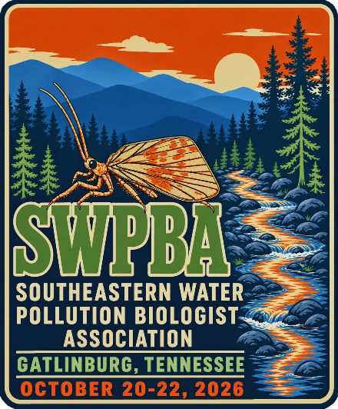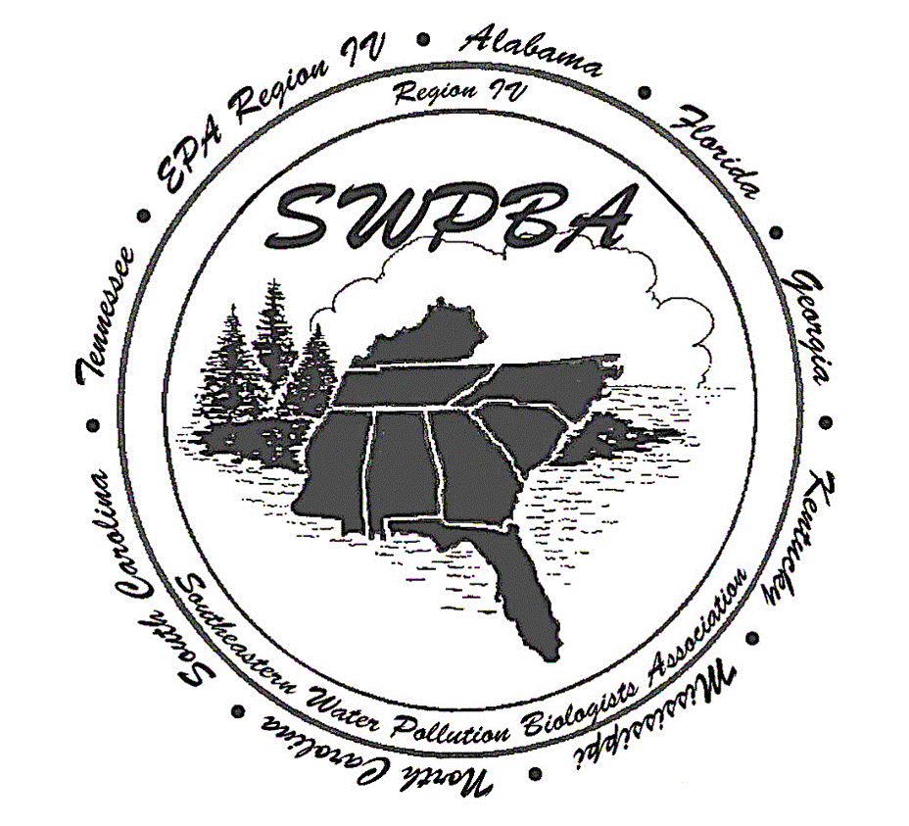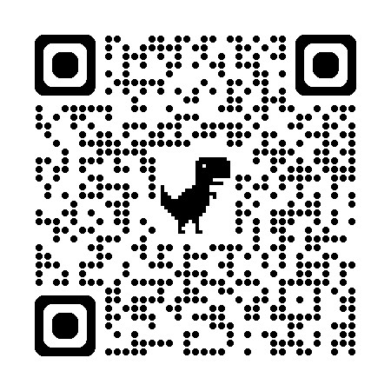
Neophylax kolodskii
DAY 1: MONDAY, OCTOBER 19TH
9:30 AM – 11:00 AM | Registration
• Location: Hotel Conference Room
11:00 AM | Field Trip #1 (Starts)
• Location: Meet in Hotel Lobby
12:00 PM – 4:30 PM | [CONCURRENT AFTERNOON TRACKS - CHOOSE ONE]
12:00 PM – 4:30 PM | Option A: Field Trip #1
• Location: Noland Divide Monitoring Station
1:00 PM – 4:30 PM | Option B: EPT workshop with Jason Robinson
• Location: Hotel Conference Room
6:00 PM – 7:30 PM | Registration & Hospitality Social
• Location: Hotel Conference Room
DAY 2: TUESDAY, OCTOBER 20TH
7:30 AM – 8:30 AM | Registration
• Location: Hotel Lobby
8:30 AM – 9:00 AM | Opening Remarks & Meeting Start
• Presenter: April Grippo, Director (TDEC - Division of Water Resources)
Session #1: All Tennessee
9:00 AM – 9:20 AM | Conservation Projects at the Tennessee Aquarium Conservation Institute
• Presenter: Emily Culp (TNACI)
9:20 AM – 9:40 AM | Aquatic Resource Alteration Programmatic Updates
• Presenter: Doug Lawrence (TDEC)
9:40 AM – 10:00 AM | TN RiverLine
• Presenter: Jennifer Webster (TN RiverLine)
10:00 AM – 10:15 AM | Morning Break
• Location: Refreshment Station
Session #2: Rainbows and Regional Monitoring Network
10:15 AM – 10:40 AM | Update on the Southeast Monitoring Project in TN
• Presenter: Debbie Arnwine (TDEC)
10:40 AM – 11:05 AM | Tennessee SEMN macroinvertebrates Updates
• Presenter: Larry Everett (TDEC)
11:05 AM – 11:30 AM | The Rainbow Reedy
• Presenter: David Eargle (South Carolina)
11:30 AM – 1:15 PM | [CHOOSE ONE LUNCH OPTION]
11:30 AM – 1:15 PM | Option A: Lunch on Your Own
• Location: Off-site
11:30 AM – 1:15 PM | Option B: SEMN Lunch Workshop
• Location: Hotel Conference Room (Participating Orgs Only)
Session #3: All HABs (Harmful Algal Blooms)
1:15 PM – 1:35 PM | TN HABs study that was recently published and the use of SPATT samplers for cyanotoxin monitoring
• Presenter: Andrea Jaegge (TDEC)
1:35 PM – 1:55 PM | South Carolina HABs
• Presenter: Emily Bores (South Carolina)
1:55 PM – 2:15 PM | Cyanotoxin monitoring project and general HABs program updates
• Presenter: Jessica Rader (TDEC)
2:15 PM – 2:30 PM | Afternoon Break
• Location: Refreshment Station
2:30 PM – 3:30 PM | State, EPA, & Tribal Updates + Q&A
• Location: Reps from each State, EPA Region IV, & Tribes
3:30 PM – 3:45 PM | Quick Break
• Location: Refreshment Station
Session #4: Biomonitoring
3:45 PM – 4:05 PM | Macroinvertebrates in Nolichucky River Pre and Post Helene
• Presenter: Beverly Brown and Tina Robinson (TDEC)
4:05 PM – 4:35 PM | biomonitoring or stressors
• Presenter: Justin Bagley (ADEM)
4:35 PM – 5:05 PM | SWPBA Business Meeting
• Location: All Members Welcome
7:30 PM – 9:00 PM | SWPBA Trivia Night
• Location: Hotel Conference Room
DAY 3: WEDNESDAY, OCT. 21ST
7:30 AM – 8:30 AM | Registration
• Location: Hotel Lobby
Session #5: Brook Trout and Macroinvertebrates
8:30 AM – 8:55 AM | Brook Trout Restoration Efforts Milestones and the Potential for Habitat Recovery and More Restoration Across Great Smoky Mountains National Park
• Presenter: Matt Kulp (GSMNP)
8:55 AM – 9:30 AM | Revising the Plecoptera chapter of Larvae of the Southeastern USA
• Presenter: Chris Verdone (NC DEQ)
9:30 AM – 9:55 AM | Why we collect biology
• Presenter: Kim Laster (TDEC)
9:55 AM – 10:10 AM | Morning Break
• Location: Refreshment Station
Session #6: Wetlands and Black Water
10:10 AM – 10:30 AM | Tennessee’s Predicted Wetland Model Tool- A Future in Wetland Determinations
• Presenter: Doug Lawrence (TDEC)
10:30 AM – 10:50 AM | Development of blackwater stream class using optical properties and DOC
• Presenter: Victoria (Tori) Ferri (South Carolina)
10:50 AM – 11:10 AM | Biological component of the blackwater stream class project Tori is leading
• Presenter: Charles (Chip) Howenstine (South Carolina)
11:10 AM – 11:20 AM | Quick Break
• Location: Refreshment Station
Session #7: “Dams and Macroinvertebrate” monitoring
11:20 AM – 11:40 AM | Raven Fork Dam Removal Project
• Presenter: Rainee Tetreault (Eastern Band of Cherokee Indians)
11:40 AM – 12:05 PM | A Decade of Incorporating Non-Wadeable Sites into South Carolina's Macroinvertebrate Ambient Monitoring
• Presenter: Justin Lewandowski (South Carolina)
12:05 PM – 1:30 PM | Lunch and learn
• Location: Provided on-site
1:30 PM – 2:00 PM | Transit Window / Free Time
• Location: Prepare for afternoon tracks
2:00 PM – 4:30 PM | [CHOOSE ONE CONCURRENT OPTION]
2:00 PM – 4:30 PM | Option A: Field Trip #2
• Location: Behind-the-Scenes: Ripley’s Aquarium of the Smokies
2:00 PM – 4:30 PM | Option B: “Taxonomy Fair” with Jason Robinson
• Location: Hotel Conference Room
4:30 PM – 8:00 PM | Banquet and Awards Ceremony
• Location: Dolly Parton Stampede (Show starts at 6:00pm)
DAY 4: THURSDAY, OCT. 22ND
Session #8: The "Potpourri" Session
9:00 AM – 9:25 AM | Tennessee Mitigation Assessment Tool
• Presenter: Sydney Norman (TDEC)
9:25 AM – 9:50 AM | Standardizing the Sampling of Per and Polyfluorinated Substances in Foams and Surface Microlayers for Surface Waters
• Presenter: Chris McArthur (EPA)
9:50 AM – 10:15 AM | Noland Divid Monitoring Station
• Presenter: John Schwartz (University of Tennessee Knoxville)
10:15 AM – 10:30 AM | Final Break
• Location: Refreshment Station
Session #9: Periphyton and Citizen Science
10:30 AM – 11:15 AM | Development of SC stream periphyton monitoring program
• Presenter: Caitlin Smith (South Carolina)
10:30 AM – 11:15 AM | SC Adopt-a-Stream Program Coordinator: SC Department of Environmental Services
• Presenter: Jaclin A DuRant (South Carolina)
11:15 AM | SWPBA 53rd Annual Meeting Adjourns
• Location: Safe travels home!

